In order to properly customs clear import shipments to China, the customs authorities are mandating additional information for both **the Master Airway Bill (MAWB) and House Airway Bill (HAWB)** (for consolidated shipments)

**The new requirements for FWB and FHL cover three areas:**

1. Mandatory information for the Shipper and Consignee
2. Other Customs information (OCI)
3. **Detailed** description of goods 🡪 Description must not be generic. For example, instead of Apparel it must be **Dresses**; instead of Animals it must be **Live Horses**

**1. Shipper & Consignee Details**

Shipper:  
Name of shipper (*mandatory for every shipment, not specially related to Chinese customs requirement)

Telephone number of shipper  
Shipper country ISO code

Shipper ***Enterprise Code\****

Consignee:

Name of consignee

Telephone number of consignee

Consignee country ISO code

Consignee ***Enterprise Code\****

**Specific** contact name for consignee

**Specific** contact telephone number for consignee

For consignees that do not have an Enterprise Code (i.e. natural persons);

An identification Card Number or Passport Number may be used. For passport the entry shall be "PASSPORT" + passport number.  In case of other ID then use "ID" + number. If no such number is available, use “9999CN” (e.g. NGOs, Entities without enterprise code).

*\*Enterprise code list attached*

**Submission Methods**

1. **For customers transmitting FWB/FHL messages in accordance with IATA Cargo-IMP:**

The additional information must be included in the **Shipper (SHP)** details, **Consignee (CNE)** details and **Other Customs, Security and Regulatory Control Information (OCI) line** of the FWB and FHL.

**FWB Example:**

FWB/16

020-12349876HAMPVG/T2K000.0

FLT/LH1234/03

RTG/PVGLH

**SHP**

/AXXXXXXXXXXXXXXXXXX GMBH U CO

/BEISPIEL STR. 111

/NORDERSTEDT

/DE/22848/TE/49691234567

**CNE**

/XXXFREIGHTLOGISTICS SHANGH

/ROOM 600 NO 22222 SUHANG ROAD

/SHANGHAI

/CN/201202/TE/8621333333333

AGT/6000/2111111/2000

/A.XXXXXXXX DEUTSCHLAND CO

/NORDERSTEDT

ACC/GEN/ABD 18DE444444444444

/GEN/CITES W-000000

CVD/EUR//PP/NVD/NCV/XXX

RTD/1/P2/K888.0/CQ/W888.0/R1.XX/T11111.1

/NC/CONSOLIDATION AS PER

/2/NC/ATTACHED CARGO MANIFEST

/3/NC/EST

/4/NC/- NOT RESTRICTED - P

/CT2473.50

OSI/UNSECURED

REF/ZCSTXLH/302-XX-XXXXXX-XX

**OCI**/DE/ISS/RA/000XX-0X

///ED/1299

/DE/EXP/M/18DE1111111111

/DE/SHP/T/EUROPEAN VAT NUMBERDE295691659

/CN/CNE/T/USCI333333333

/CN/CNE/CP/JOHNSMITH

/CN/CNE/CT/86219999999

In case of consignees without Enterprise Code (i.e. natural persons), a passport or ID can be used. For entities without Enterprise Code (NGO, Ministries) a dummy (9999+Country code) may be used. The information is to be shown as follows:

(Excerpt from OCI line)

/FR/SHP/T/PASSPORT12345678 OR

/CN/CNE/T/PASSPORT987654321 OR

/FR/SHP/T/9999FR OR

/CN/CNE/T/9999CN

**FHL Example:**

FHL/4   
MBI/020-12349876HAMPVG /T2K000.0

HBS/HAM09037714/HAMPVG/2/000.0//PIANOS

TXT/PIANOS

OCI/DE/ISS/RA/000XX-XX

///ED/XXXX

/DE/EXP/M/18DE112222233333

/DE/SHP/T/EUROPEAN VAT NUMBERDE11111140

/CN/CNE/T/USCI99999999999999

/CN/CNE/CP/MAXLEE

/CN/CNE/CT/86 215666666666

**SHP**/EXAMPLE GMBH

/FIFTH STREET 10-12

/HAMBURG

/DE/22525/TE/49403333333

**CNE/**THE PIANO PEOPLE CO

/NO.444 KUNG FU ROAD

/SHANGHAI

/CN/200131/TE/862112345678/FX/862111111111

***Optional – AEO (Authorized Economic Operator) code***

***E*** is the correct customs information ID

Format: Country Code + AEO Code

Example: SHP/E/DE1234567

1. **For customers using the LCAG Customer Portal;**

The required data can be capture in the **Participant Tab, Shipper and Consignee**, and **Additional Info Tab, Other Customs Information section**

**Example: 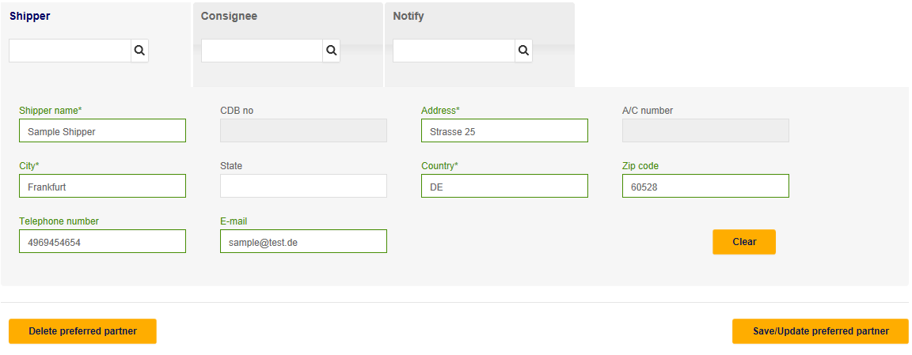Shipper and Consignee name is anyway a mandatory field, Telephone number is required for shipments to China for both Shipper and Consignee.**

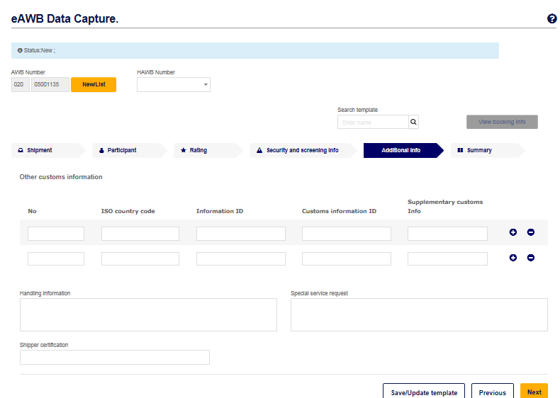

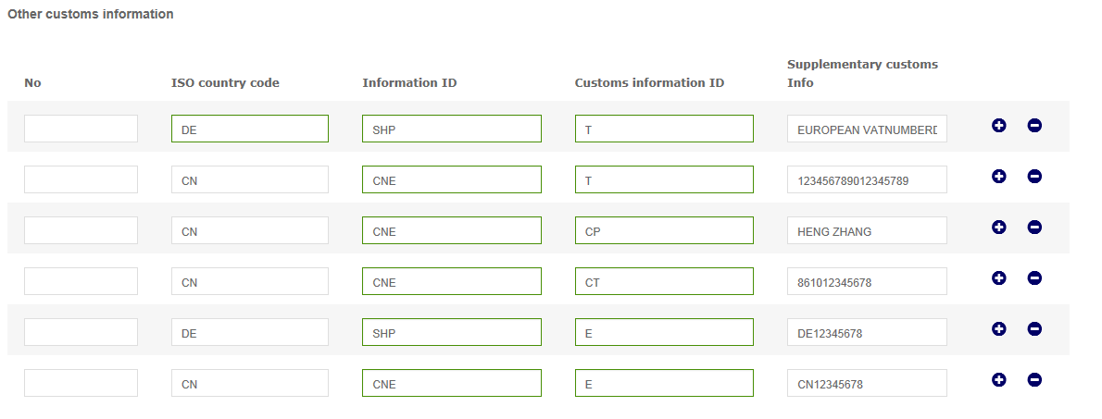

EUROPEAN VAT NUMBER DE12345678

USCI12345455

1. **Manual submission:**

All necessary data must be available at time of acceptance both on the **Master Airway Bill (MAWB) and House Airway Bill (HAWB)** (for consolidated shipments):

Name of shipper (*mandatory for every shipment, not specially related to Chinese customs requirement)

Telephone number of shipper  
Shipper country ISO code

Shipper ***Enterprise Code\****

Name of consignee

Telephone number of consignee

Consignee country ISO code

Consignee **Enterprise Code\***

**Specific** contact name for consignee

**Specific** contact telephone number for consignee

**Shipments to China delivered with incomplete or missing data will not be accepted by LCAG.**

**Enterprise Code Description**

1. The number must be entered as described, e.g. for county AF you must enter:

**T/SIREN NUMBER1234567**

or in case of Germany:

**T/EUROPEAN VAT NUMBER 1234567**

**IF** the format shows blanks/spaces between the entries you must enter these

**EUROPEAN <BLANK> VAT <BLANK> NUMBERDE1234556**

**No other format or abbreviation of the “Enterprise Code Description” is allowed.**

2. Examples:

|  |  |
| --- | --- |
| **Allowed** | **Not Allowed** |
| EUROPEAN VAT NUMBERDE1234567 | EU VAT No. DE1234567 |
| EUROPEAN VAT NUMBER DE1234567 | EUROPEANVATNUMBERDE1234567 |
| EUROPEAN VAT NUMBER.DE1234567 | EUVATNO.DE1234567 |
|  | VATNUMBERDE1234567 |

